08_MovieMining_Part2

Discovering Trends in Film Runtime

Caleb Stillman

Computer Science Post Bacc.

University of Colorado Boulder

Boulder Colorado United States

cast9172@colorado.edu

Graydon Sinclair

Computer Science Post Bacc.

University of Colorado Boulder

Boulder Colorado United States

grsi7978@colorado.edu

Stephen Tynan

Computer Science Post Bacc.

University of Colorado Boulder

Boulder Colorado United States

stty1424@colorado.edu

Problem Statement / Motivation

Group 8’s project goal is the mining of data from a repository with information on over 950,000 films. The mining will have a focus primarily on the runtime feature of the data. It will look at both its impact on other features and the way other features impact it.

Some questions that will be answered via data examination include whether it is possible to predict the runtime of a film based on its genre, country of origin, and/or date of release. Another goal is to identify the ideal film length associated with high ratings.

The intent of determining if these relationships exist, and to what extent, is that this information could be applied within the film industry. This application would theoretically help produce movies with a greater likelihood of positive public reception, resulting in an increased box office.

Literature Survey

A survey of existing literature suggests that some work has been done to examine the impact of runtime on other facets of films. However, the work has been minimal.

A piece in Cognitive Research Journal [1] speaks to runtime tangentially as it related to trends in the pacing of films throughout history. However, the author examines a limited 210 films and only includes films within an arbitrary runtime cutoff at the two-and-a-half-hour mark.

Another article from Film and Digital Media [2] does focus on runtime but is a shallow piece. The intent of this project is to mine further information than is presented in this strictly topical article.

IMDBPro [3] published an article that focuses on how the success of a film is measured, which is related to this project, but it does not speak to runtime at all. This may lead one to believe that runtime is an overlooked aspect of success.

Proposed Work

This project will begin with EDA, including concurrent data cleaning and preprocessing.

As part of the EDA process outliers in the data will be identified and handled. For instance, a cursory glance at the data shows that there are movies over the 7-hour mark in the data set. Both whether these are actual movie lengths or bad data, and how the outlier is handled needs to be determined. Some of the outliers may be determined from area expertise instead of raw data. Such as the fact that the data set was last updated in July 2024, meaning that any films with release dates past June 2024 likely have bad or limited ratings data as only select viewers may have seen it. This kind of outlier will also need to be determined and handled.

Not only will outliers need to be either removed, transformed, or replaced depending on the type of feature but the overall data characteristics will be recorded and documented. During EDA visualization will be leveraged to help determine if any patterns arise. Visualizing the data and documenting characteristics will help understand the distributions and relationships between features and may influence which features are kept for which parts of the project.

In an earlier iteration of this project, it was discussed that other data sets may be brought in to get additional information on box office, budget, and ratings for films. Since the initial planning it has been decided to abstain from these additions. The primary data set from Letterboxd includes viewer ratings which can be indexed as a success metric. It was determined that there is already a large sum of literature on the analysis of the box office and budgets of films [3] and additional research would be less impactful than that pertaining to runtime. As there are no other data sets being leveraged there is less data preprocessing and integration than initially planned.

Some integration is still required however, as the Letterboxd data set is split into ten separate sub-sets in CSV format. A primary key is shared across all these sub-sets allowing for merging during data frame creation. Other steps in the preprocessing will include transforming categorical data into numerical, using one-hot encoding, so that the information can be more easily parsed. Depending on which evaluation techniques are being leveraged there may also be instances of classification occurring, e.g. the assignment of ratings to categories such as great, good, okay, poor, and bad.

The evaluation stage comes after the EDA, cleaning, and preprocessing, wherein primary features and correlations will be discovered. Mean Squared Error (MSE), regression analysis, Mean Absolute Error (MAE), precision, recall, F1 scores, and lift are just some of the measurements that will be used to determine the strength of correlation and general relationships between the features mined.

One thing we need to determine moving forward is a set of binary metrics if we still plan on using metrics such as precision, recall, lift, and f1 scores. We have a few options and need to determine which will give the best results, we could build out models for specific rules, for example for rating>=3, release country = all, is minutes >= 120. In order to explore trends within the model and develop a deeper understanding. Or we could determine an arbitrary rule such as:

If minutes >100:

bin_min = 1

we can play around with both options to see which provides the most interesting data and choose which to incorporate in the final report at that point.

Data Set

The data set is sourced from the website / app Letterboxd and hosted on Kaggle [4]. Letterboxd is a social media film site that aggregates film data and viewer interactions such as ratings, likes, and views with said films. The data set has been downloaded locally in case of an unforeseen event where it is no longer available via the web.

The data set is quite large. It includes 10 sub-sets of data and has information on over 950,000 films. Each of these films can have many entries across the sub-sets of data. For instance, one film may have 3 genres (rows) of data in the genre sub-set alone. The sub-sets include information on genres, country of origin, actors, crew, studios, languages, poster urls, release type and date information, themes, and the movies themselves. The sub-sets vary in size. As mentioned above each film can have many rows in each sub-set other than the movies sub-set. No sub-set has more than seven columns (including the primary key).

The data set is updated annually. It was last updated July 2024, meaning the runtime data included is very up to date for current research. However, when looking at some features, such as ratings, it may be important to note that this feature may not have stabilized for a movie that came out close to the data set update. This is another candidate for domain knowledge-based outliers for certain features.

It is important to note that most of the data in these data sets is categorical. Therefore, if regression is to be done on any of these subsets or the final monolithic set then some encoding will be required.

Evaluation Methods

For evaluation accuracy measurements will be used when looking at the success of classification prediction. Lift will be measured to look at the performance and importance of the associations found. MSE will be used for regression analysis such as the prediction of runtimes. Precision and recall will be used to measure the success of model predictions. F1 scores will be leveraged for tasks such as genre classification. Matplotlib and Seaborn will also be used to create visual plots to aid in evaluation, such as providing a comparison between predicted and known values.

Tools

Python, and its associated libraries will be the primary tools for this project. The following associated libraries will be used for mining the data; Pandas for producing, merging and editng data frames, NumPy to aid in calculations, Seaborn will be used for visualizations and plotting graphs, charts, and plots while Matplotlib provides the support we need for seaborn. We will be using sci-kit too implement regression modeling and analysis as well as provide additional functionality for the data frames, such as splitting variables to test and train. There was initial discussion around the use of Orange, but due to the size of the data set it was determined to not be ideal for this project. We found the size of the data has limited the tools we could use, the only option for data cleaning and merging ended up being pandas through, We found after merging the data our df was in the millions, with excels support limited around 1.4 we found ourselves unable to even view the full dataset. After cleaning and one-hot encoding we were able to limit the number of rows to under 20k and were able to view the full dataset. This provided an interesting opportunity to review the limits of different tools and select one that would solve our problem.

Milestones

1 Milestones Completed

1.1 Identification

Expected completion date: 10/01/24

1. Identification of viable datasets

2. Identification of the primary and secondary features.

2.1 EDA – Cleaning

Expected completion date: 10/15/24

Cleaning of data:

Removal of NaN and bad data

Identification and potential removal of outliers (by both domain expertise and statistical determination)

2.2 Data Preprocessing

Expected completion date: 10/31/24

Data has been combined into a singular set containing all pertinent data.

Transformation of data – e.g. one-hot encoding

Trend analysis and precursory evaluations

2. Milestones To Do

3.1 Analysis

Expected completion date: 11/30/24

Complete research and analysis on the data. Apply evaluation methods and add visualizations.

Build a predictive model and compare model to test data.

Apply methodologies to the following big questions (more may arise during EDA):

1. What is impact of runtime on rating? / What is the ideal runtime?

2. What is impact of genre on runtime?

3. What is impact of country of origin on runtime?

4. What is the impact of runtime on rating by country of origin?

5. What is the impact of runtime on rating by genre?

4.1 Finalize Results

Expected completion date: 12/6/24

1. Finalize evaluation

2. Synthesize results – determine if there are new questions to be asked

3. Produce final presentation.

Results So Far

As mentioned in the Proposed Work section above, we have leveraged visualizations during our preliminary EDA to determine whether any patterns arose in the data, both those we expect to find or those we might find surprising. To this end, we fitted and trained a linear regression model on the “minutes” (of runtime) feature. This was used to plot a few graphs: Actual vs. Predicted Runtime by Rating, Actual vs. Predicted Runtime by Date, Actual vs. Predicted Linear, and Rating vs. Minutes. These will each be addressed in turn below.

The Actual vs. Predicted Runtime by Rating graph served well as a test of our preliminary linear regression model.

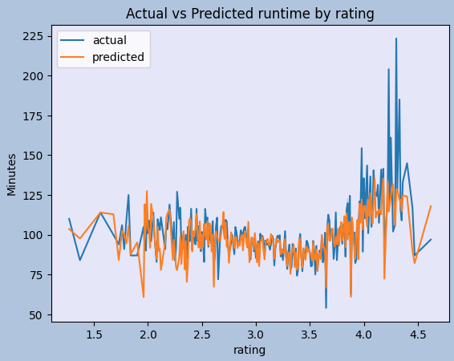

The results of the graph show an encouraging level of correlation between the actual and the predicted runtimes by rating, particularly among middle-range values, indicating that one of our most important questions is indeed worth further investigation. That said, the graph revealed that our model could use tuning to provide better predictions around the lower and upper ranges of ratings.

Another feature we graphed with runtime was release date. Our interest in a preliminary graph of these features together at this early stage was primarily to discern how trends in runtime have developed over time.

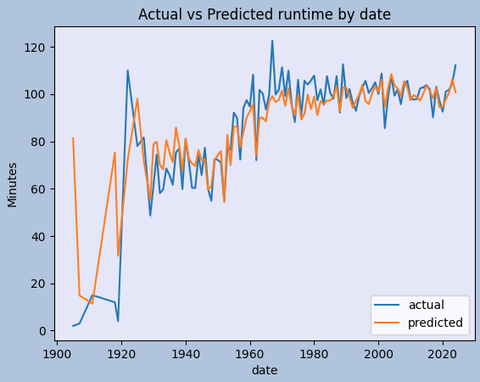

The results of this graph did largely confirm our expectations, showing that early films had a much shorter average runtime. There was a large spike in average length of films in the early 1920’s, stabilizing at a much higher range of runtime (60-80 minutes, up from <20 minutes) beginning around the release of the first non-silent film, The Jazz Singer, in 1927. Once sound was introduced, runtimes stayed in roughly the 60-80 minute duration range for about the next 20 years. Starting in the 50’s, film length began to creep up over the course of the next decade, stabilizing again in the late 60’s/early 70’s to an average length range between 90 and 110 minutes, a trend in film length which has continued through the present day. Here again, we tested our linear regression model and saw that our model predictions follow actual values to an encouraging degree (the exception being in the earliest two decades of film history).

In speaking about our model, our next plot was of actual runtime values vs. our predicted linear regression values, to determine the initial efficacy of our linear regression model.

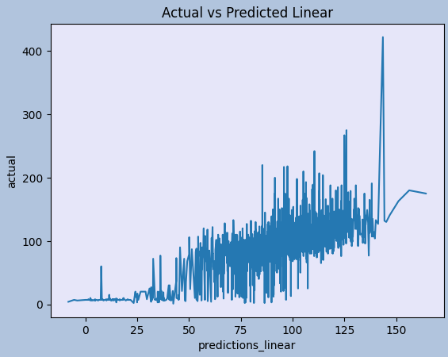

One thing of note in this graph is that one can see that there are not many films included in the dataset with runtimes between 0 and 25 minutes, and there are a few included in our dataset with runtimes between 25-40 minutes, but after this point is where the data really spikes. This is as expected, as the dataset is meant to capture feature films. The Academy of Motion Picture Arts and Sciences, the American Film Institute, and the British Film Institute all consider feature films to be those with runtimes greater than 40 minutes [5]. We are able to see that the data is most tightly clustered around the 45-138 minute range, which is also to be expected, as we could see on the previous graph as well. That said, this graph also shows that we need to work on fine-tuning the performance of our linear regression model. We can also conclude that we may want to look into other metrics such as RMSE to supplement the findings of our linear regression model.

Lastly, we created a graph of the pure rating vs. minutes of runtime, without also graphing the results of our model.

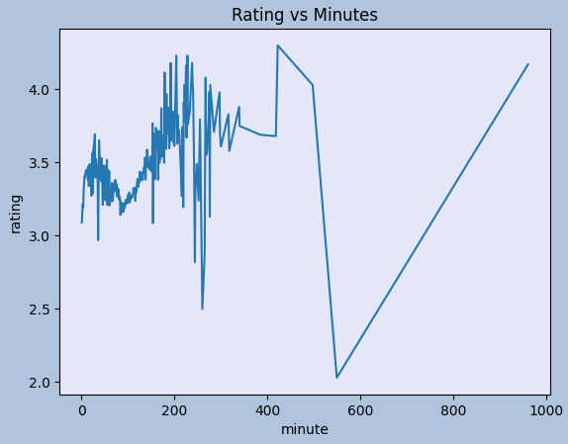

The most striking revelation of this plot is that we have further cleaning on outliers to complete, as there is not much data worth noting past the 350 minute mark, but we have data in the 400-1000 minute range which is probably contributing to the skewing of our linear regression model.

All told, our results thus far have been largely encouraging that we’re on the right track, seeing data that backs up conclusions we would expect about known runtime trends, and that we have at least a good start on a prediction model for answering some of our proposed questions.

REFERENCES

[1] James E. Cutting, 2016. The evolution of pace in popular movies, Cognitive Research Journal DOI: https://cognitiveresearchjournal.springeropen.com/articles/10.1186/s41235-016-0029-0

[2] acmk19. 2017. Time Isn’t Money: Does Runtime Affect a Film’s Box Office?, Film and Digital Media, DOI: https://filmanddigitalmedia.wordpress.com/2017/10/19/time-isnt-money-does-runtime-affect-a-films-box-office/

[3] How is the success of films and TV shows measured?, IMDBPro DOI: https://pro.imdb.com/content/article/entertainment-industry-resources/featured-articles/how-is-the-success-of-films-and-tv-shows-measured/GLFTC8ZLBBUSNTM3

[4] Letterboxd Kaggle Data. DOI: https://www.kaggle.com/datasets/gsimonx37/letterboxd/data

[5] Feature film. Wikipedia: https://en.wikipedia.org/wiki/Feature_film